Assignment - 4

|  |  |
| --- | --- |
| **Student Name/ID Number:** | Triyana Rahmat – BDSE-0922 |
| **Academic Year:** | 2023/2024 |
| **Module Name:** | Front End Web Development |
| **Project Title:** | Single Page Application |
| **Submission Date:** |  |

Date:

Student signature:

I certify that the work submitted for this assignment is my own and research sources are fully acknowledged.

**Learner declaration**

1. CHANGE PRODUCT PRICE.

Here are a screenshoot of product price contains mushrooms,potatos,carrots,and tomatoes.

Mushrooms : SGD 3,26

Potatos : SGD 1,95

Carrots : SGD 1,30

Tomatoes :SGD 0,98

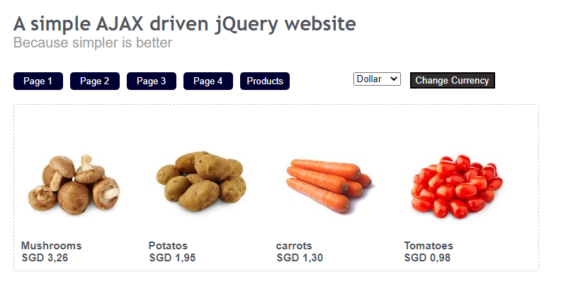

1. CURRENCIES

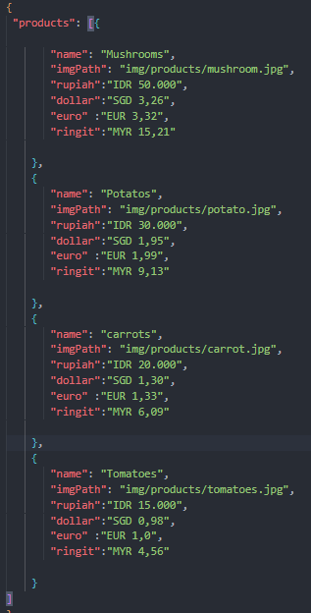

1. Client-slide CALL PRODUCT ID

When the page is loaded, the code will check the URL and load the default page content. Furthermore, when the user clicks on a navigation link, the code will load the page content corresponding to the clicked link using AJAX. The code also uses the setInterval() function to check the URL every 250 milliseconds to ensure that the appropriate page is loaded. Finally, the code also checks the URL when the browser's back or forward buttons are used and loads the appropriate page content.

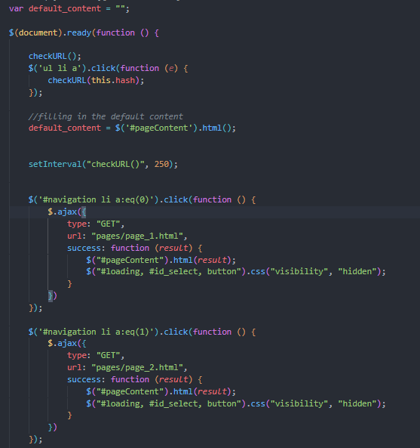

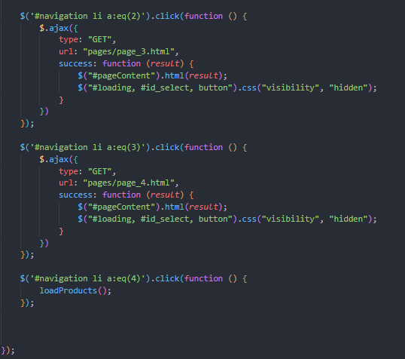

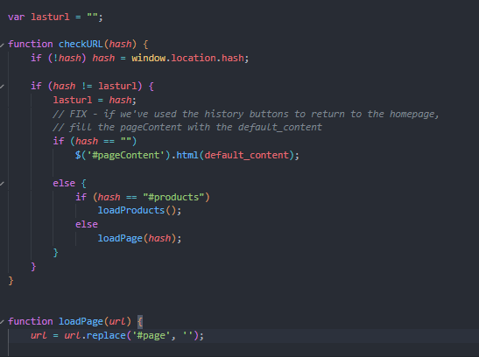

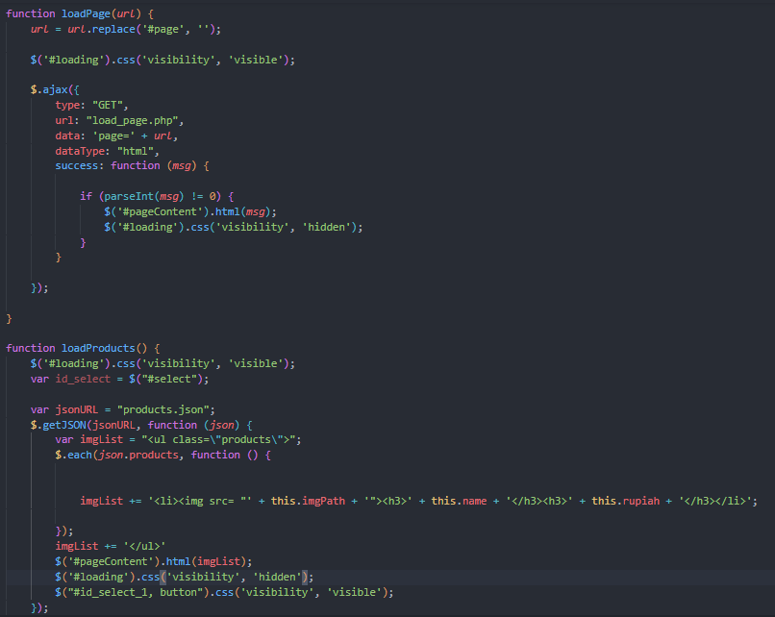

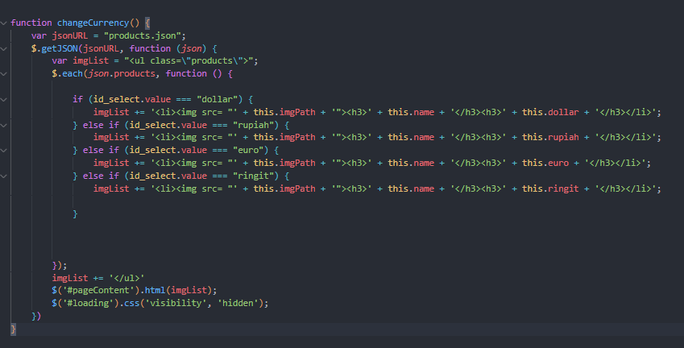

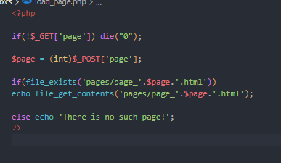

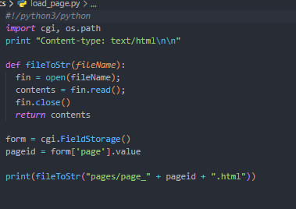

1. DISPLAY AREA MAIN CONTENT PRODUCT :

This is a some pictures of the main contents area of the products such as lists of the currencies, and the products contains mushrooms,potatos,carrots, and tomatoes with the price

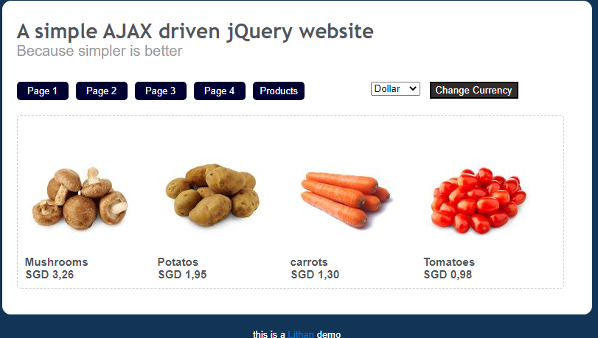

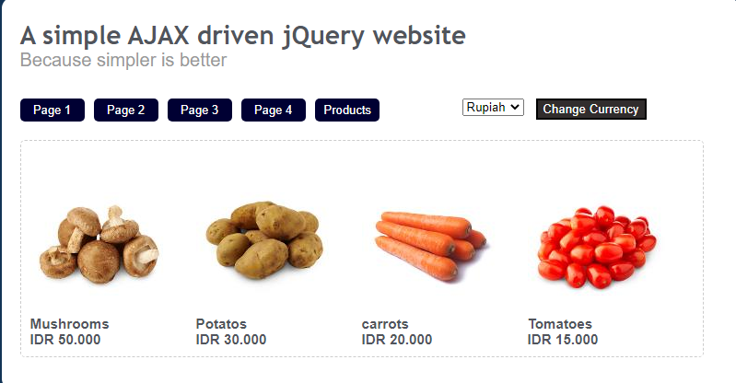

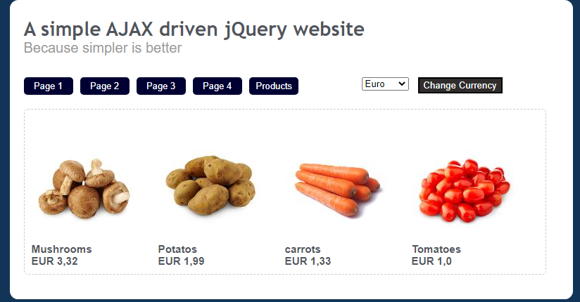

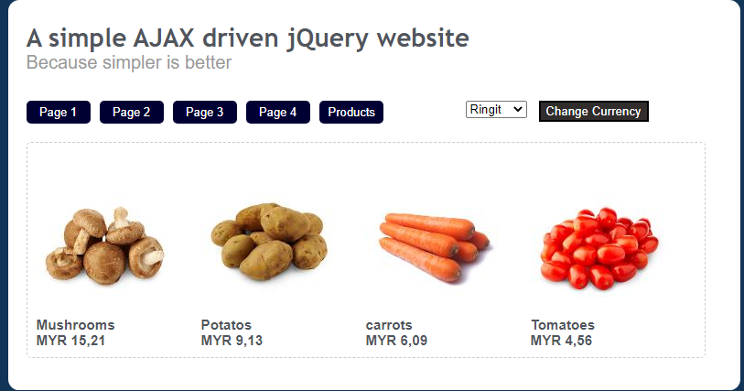

1. Xampp



XAMPP (stands for Cross-Platform, Apache, MySQL, PHP, and Perl) is a free and open-source web server solution developed by Apache Friends. It provides an easy-to-install package that includes Apache HTTP Server, MySQL database, PHP, and Perl programming languages, allowing developers to set up a local web server environment for testing and development purposes on their own computer.

1. Apache tomcat



Apache Tomcat is an open-source web server and servlet container developed by the Apache Software Foundation. It provides a Java-based environment for running Java Servlets, JavaServer Pages (JSPs), and other Java web applications. Tomcat implements the Java Servlet and JavaServer Pages specifications, allowing web developers to create dynamic web pages and applications using Java technology. It is widely used as a web application server for running Java-based web applications and is popular among developers due to its simplicity, flexibility, and scalability

1. Ajax

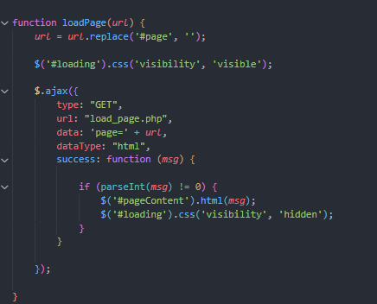

function AJAX to dynamically load web page content. This function accepts a URL as a parameter, makes a request to a PHP script that loads the page content, and updates the web page with the received content without reloading the entire page. This makes web pages more responsive and interactive for users.

Get/POST

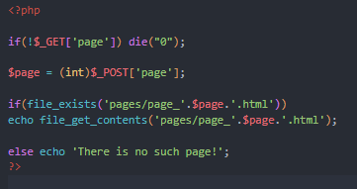

PHP script that checks if there is a 'page' URL parameter received via the GET method. If not, the script will return 0 and stop further code execution.

If there is a 'page' URL parameter, the script will take the 'page' value sent via the POST method and convert the value to an integer using the (int) function.

1. Client-side

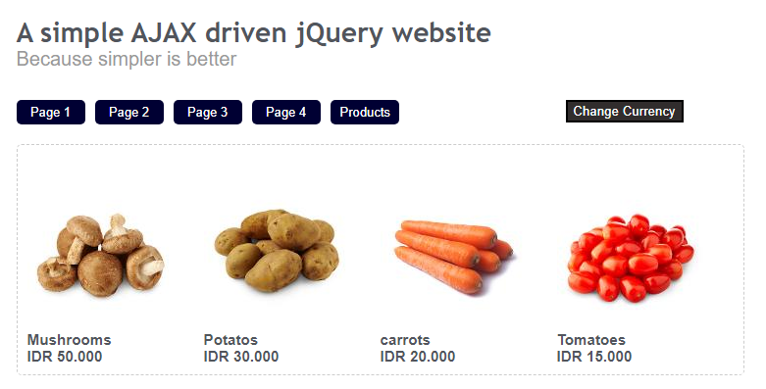

refers to the part of the web application that is executed on the client side or on the user side. This includes all code that runs in the user's browser, such as HTML, CSS, and JavaScript. Client-side code is responsible for displaying web pages and managing user interactions with those pages, such as submitting forms, loading dynamic content, and providing visual feedback for user actions. This allows web applications to display dynamic and interactive content, thereby making the user experience more engaging and responsive.

1. Serverside

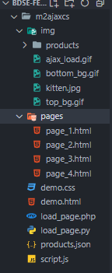

Server-side refers to the part of the web application that is executed on the server side. This includes code written in server-side programming languages ​​such as PHP, Python, and so on. Server-side code is responsible for managing requests from clients and providing appropriate responses, such as processing forms, validating data, accessing databases, and building web pages to be sent to clients. Server-side code also ensures the security and reliability of web applications, and performs data maintenance and processing behind the scenes. This allows web applications to access resources hidden from the user and ensures data consistency and integrity

1. DNS

DNS (Domain Name System) is a system used to convert easy-to-remember domain names into IP addresses that are used by servers on the internet.

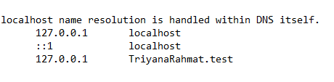

1. VHOSTS

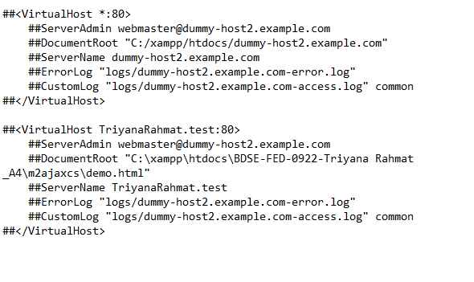

Vhosts or Virtual Hosts is a feature on a web server that allows a server to handle multiple websites on the same physical machine using the same IP address. In a Vhosts configuration, each website is assigned a "virtual host" or virtual host associated with a directory on the server. When the server receives a request to access a website, it determines the appropriate virtual host and then directs the request to the relevant directory. This feature allows the server to run multiple websites separately by allowing each website to have separate directories and configurations. This is especially useful in a shared hosting environment where multiple websites must run on the same server with limited resources.